Course Name- Problem solving using C
NIBHA KUMARI
BATCH: 4

Lab 2: Problems based on Data Types, Memory Models & ASCII
Question 1: Employee Salary Analyzer
A company stores employee salary details using different data types.

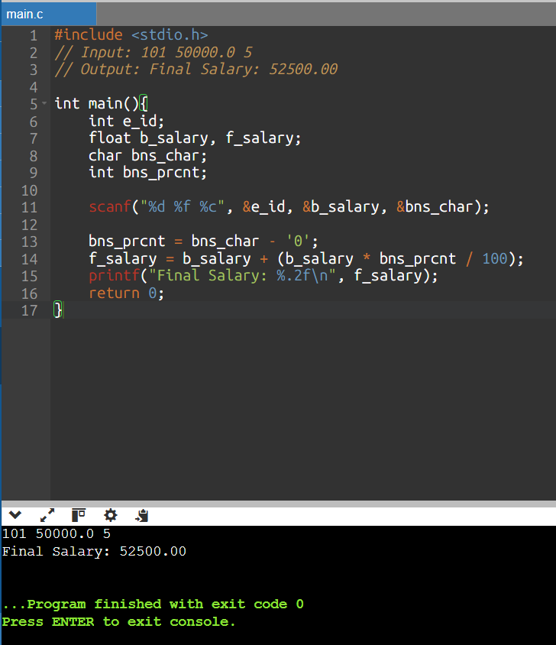

CODE
#include <stdio.h>

int main(){
int e_id;
float b_salary, f_salary;
char bns_char;
int bns_prcnt;

scanf("%d %f %c", &e_id, &b_salary, &bns_char);

bns_prcnt = bns_char - '0';
f_salary = b_salary + (b_salary * bns_prcnt / 100);
printf("Final Salary: %.2f\n", f_salary);
return 0;
}

Question 2: ASCII-Based Password Validator
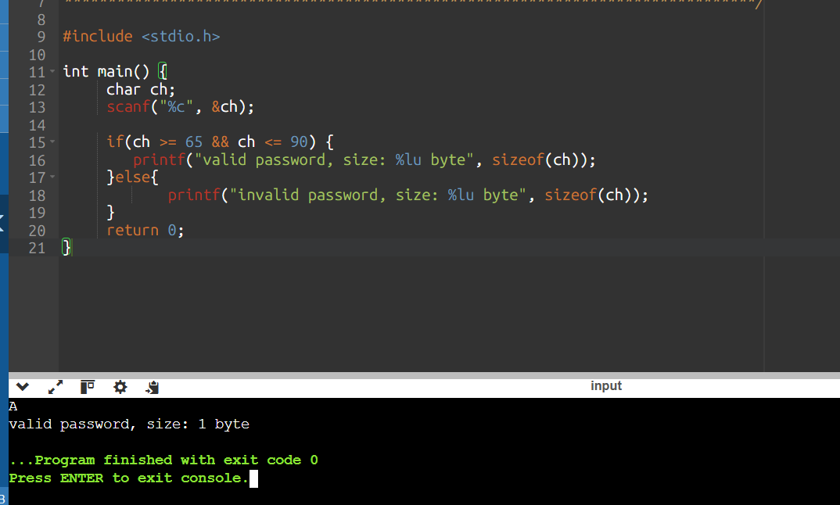

#include <stdio.h>

int main() {
char ch;
scanf("%c", &ch);

if(ch >= 65 && ch <= 90) {
printf("valid password, size: %lu byte", sizeof(ch));
}else{
printf("invalid password, size: %lu byte", sizeof(ch));
}
return 0;
}

